CERAS TILES WEBSITE

Project Documentation

TITLE PAGE
Project Title: CERAS Tiles Website
Submitted By: Noor un nisa Sheikh
Group Members:
- Zahra Tur Riaz Asad – student1704119
- Fabeha - student1704121
- Kanwal Asad - student1704116
- Noor un nisa sheikh - student1707580
- Noreen Khalid - student1703376
Supervisor: Miss Miaira
Batch: 2511B1
Institute: Aptech Learning
Submission Date: 30 March, 2026.

TABLE OF CONTENT
- Introduction
- Group Members
- Acknowledgments
- eProject Synopsis
- Problem Definition
- Problem Statement
- Project Scope
- Functional Requirements
- Non-Functional Requirements
- Task Sheet / Project Planning
- Project Design
- System Diagrams
• Flowchart
• DFD Level 0
• DFD Level 1
- Process Diagram
- Conclusion

1. Introduction
The CERAS Tiles Website is a web-based platform designed to showcase a variety of ceramic tiles and related products. The purpose of this website is to provide customers with an easy and convenient way to explore tile designs and product categories without visiting a physical store.
The website is developed as a single-page responsive website using modern web technologies such as HTML5, CSS3, Bootstrap, JavaScript, and jQuery. It allows users to browse different types of tiles, view product images, and learn about their features.
The website also provides additional sections such as product comparison, downloadable catalogues, expert guidance, and contact information, making it useful for customers who want to select suitable tiles for homes, offices, or commercial spaces.
The main objective of the project is to demonstrate the implementation of web development concepts learned during the course and apply them in a practical real-world scenario.

2. Group Members
The following students participated in the development of this project:
Student Name | Student ID
Zahra Tur Riaz Asad | student1704119
Fabeha Nadeem | student1704121
Noor un nisa Sheikh | student1707580
Noreen Khalid | student1703376

3. Acknowledgments
The first, we would like to express our special thanks of gratitude to our
teacher Miss Maira, who helped us a lot in finalizing this project within
the limited time frame, valuable counselling and assistance for the
accomplishment of this project.
Secondly we would also like to thank the eProject team at Aptech Head
Office, who gave us the golden opportunity to do this wonderful project about
CERA’S .
Thirdly, we also thank the eProject team, some of the benefits are as under:
• Re-enforcement of skills happens in the experiential learning process.
• A mentor, ensuring that we do not get drifted, constantly guides us.
• It gives us a lot of confidence to face an interview as we have worked on
a project. We can explain virtually everything on the subject we have learnt.

4. E-Project Synopsis
The CERAS Tiles Website is developed to display and organize different types of tile products in an easy-to-use web interface.
The website allows users to:
- Explore various tile categories
- View tile images and short descriptions
- Compare different tile types
- Download product catalogues
- Access educational content about tiles
- Contact the company through email and map location
The website is designed to be responsive and user-friendly, ensuring that users can easily navigate between different sections.
Technologies used in the project include:
- HTML5
- CSS3
- Bootstrap
- JavaScript
- jQuery
- Geolocation API (Google Maps)

5. Problem Definition
In many traditional tile businesses, products are mainly showcased in physical stores or showrooms. Customers who want to view different tile designs must visit the store personally in order to explore the available options. This process can be inconvenient, especially for customers who want to compare multiple tile styles, colors, or categories before making a decision.
Visiting stores repeatedly to check different products can be time-consuming and sometimes inefficient, particularly for customers who are planning home construction, renovation, or interior design projects. In many cases, customers may not have enough information about the available tile varieties until they physically see them in the showroom.
Additionally, businesses that do not have an online presence may find it difficult to reach a wider audience and effectively display their product range. Without a digital platform, customers cannot easily explore products, learn about their features, or understand the different types of tiles available for various spaces such as bathrooms, kitchens, living rooms, and outdoor areas.
Therefore, there is a need for an online platform that allows customers to browse tile products, view images and basic features, and explore different tile categories conveniently. Such a platform helps customers gain a clear understanding of available products before visiting the physical store, making the buying process more efficient and informed.
The CERAS Tiles Website addresses this problem by providing an organized and accessible web interface where users can explore tile designs, compare different options, and access useful information before going to the store to place their order.

6. Problem Statement
Customers require an efficient and accessible method to explore different tile designs and product features without visiting a physical store.
A web-based platform is required to:
- Display tile categories
- Provide product information
- Allow product comparison
- Provide downloadable catalogues
- Offer expert guidance for tile selection
- Provide contact details and location information

7. Project Scope
The scope of the CERAS Tiles Website includes the following features:
- Displaying different categories of tiles such as wall tiles and floor tiles
- Showing tile images and brief product descriptions
- Providing downloadable product catalogues
- Allowing users to compare tile types
- Providing an expert corner with guides and educational resources
- Displaying contact information with map location
- Creating a responsive layout compatible with multiple devices
The project focuses on creating a single-page website that organizes all information into different sections for easy navigation.

8. Functional Requirements
Functional requirements describe the operations and features that the system must perform.
The system should:
- Display tile categories
- Show tile product images and descriptions
- Provide navigation between different tile categories
- Allow users to download tile catalogues
- Allow users to compare different tile types
- Display expert resources such as blogs and guides
- Display company contact details
- Show the company location using map integration

9. Non-Functional Requirements
Non-functional requirements describe how the system performs its functions.
The system should:
- Provide a clean and user-friendly interface
- Load quickly and efficiently
- Be compatible with major web browsers
- Be responsive on different screen sizes
- Display images and content clearly
- Ensure easy navigation between sections

10. Task Sheet / Project Planning
The project was completed in several stages:
- Understanding project requirements
- Planning the website layout and structure
- Designing the homepage and navigation menu
- Creating tile categories and product sections
- Adding tile images and descriptions
- Implementing interactive features using JavaScript and jQuery
- Adding contact information and map integration
- Testing the website on different browsers
- Preparing project documentation

11. Project Design
The project is designed as a single-page responsive website with multiple sections.
Main sections of the website include:
- Home Section
- E-Catalogue Download Section
- Wall Tiles Section
- Floor Tiles Section
- Special Tiles Section
- About Us Section.
- Reviews Section
- Contact Us Section
- Blogs Section
- Tiles Comparison Section
- Tiles Guide Section
- Tiles Calculator Section
- Educational Videos Section
- Footer
Bootstrap grid system is used to organize content and create a responsive layout.

12.System Diagrams

Flowchart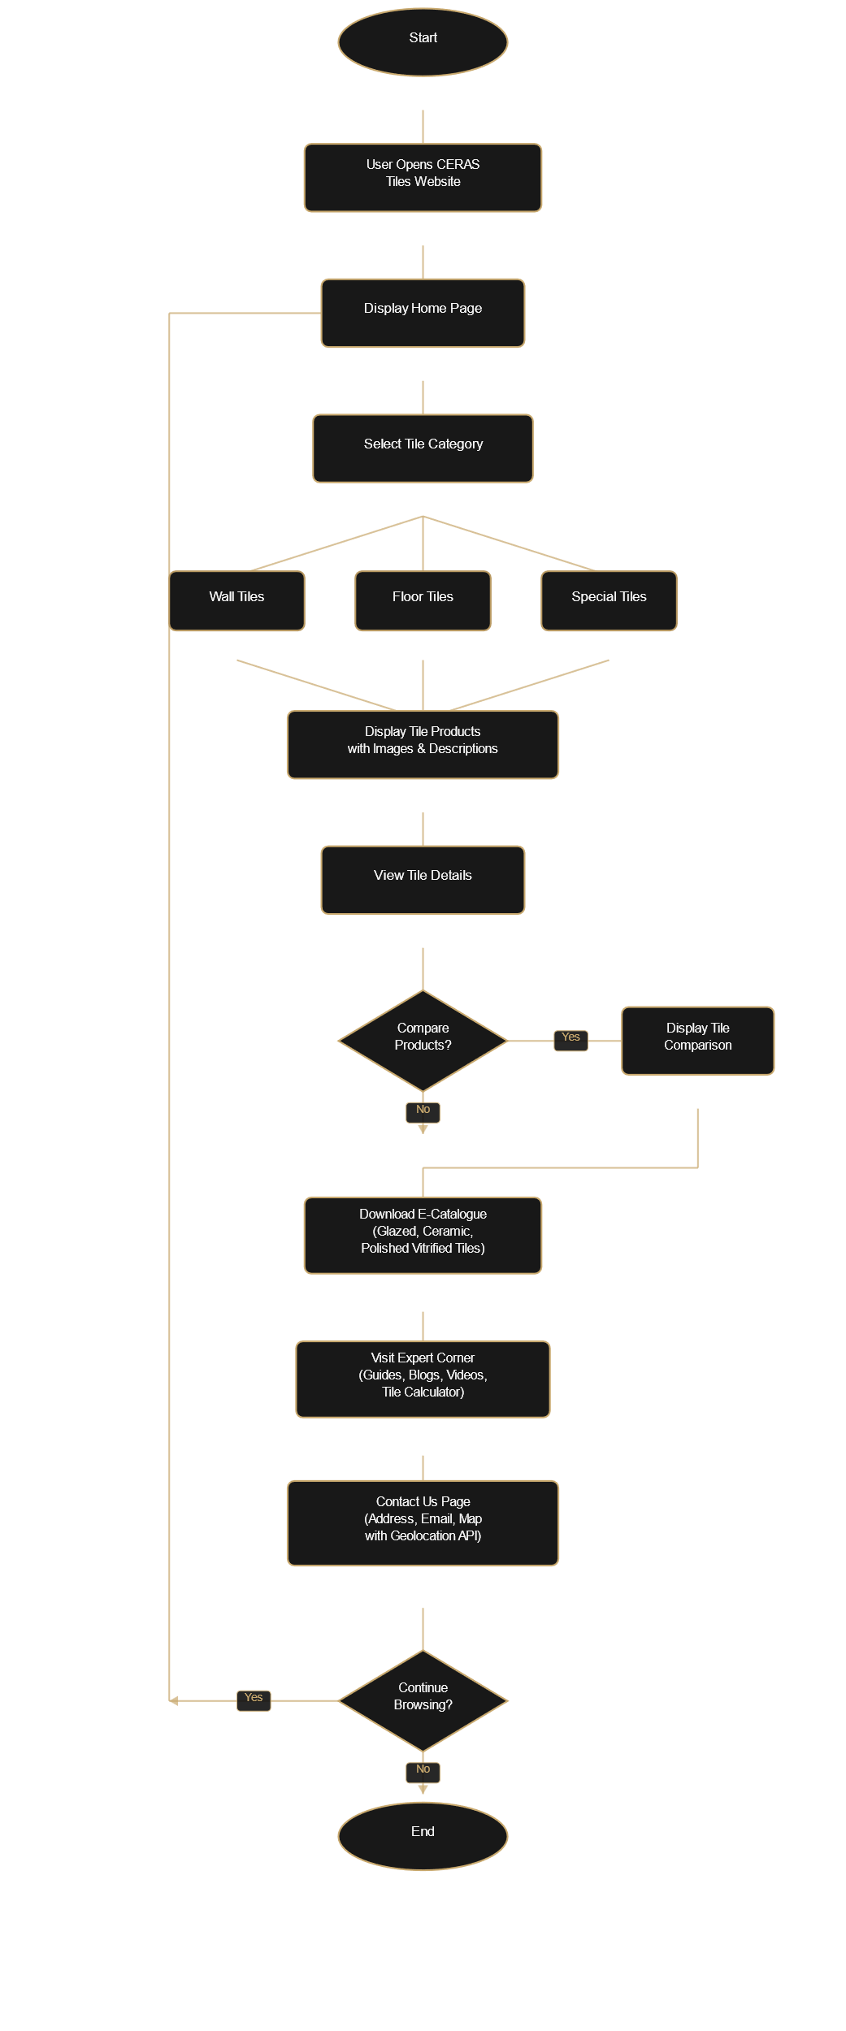

The flowchart represents the overall working process of the system from user interaction to product exploration.

DFD Level 0
Level 0 Data Flow Diagram shows the interaction between the user and the website system.
User → Website → Product Information → Display Results

DFD Level 1
Level 1 DFD provides more detailed representation of system components such as:
- Tile Categories
- Product Information
- Catalogue Downloads
- Contact Information

13. Process Diagram
The process of using the website is as follows:
- The user opens the CERAS Tiles Website.
- The user navigates through different tile categories.
- The user views product images and descriptions.
- The user may compare tile products.
- The user may download product catalogues.
- The user may visit the expert corner for guidance.
- The user can view the contact page to locate the company or send an email.

14. Conclusion
The CERAS Tiles Website successfully provides an online platform for displaying tile products and related information.
The website is designed with a clean layout, responsive interface, and simple navigation structure to ensure a positive user experience.
This project demonstrates the practical implementation of web development technologies and helps improve understanding of website design and development concepts.

